**Project Report**

**1.   INTRODUCTION**

**1.1   Project Overview**

This Project **"EXPLORATORY ANALYSIS ON RAINFALL DATA IN INDIA FOR AGRICULTURE"** relys on helping our farmers and agriculturalist in India to predict the rainfall rate for a month in their respective state.Rainfall has been a major concern these days. Weather conditions have been changing for time being. Rainfall forecasting is important otherwise, it may lead to many disasters. Irregular heavy rainfall may lead to the destruction of crops, heavy floods that can cause harm to human life. It is important to exactly determine the rainfall for effective use of water resources, crop productivity, and pre-planning of water structures.This comparative study is conducted concentrating on the following aspects: modeling inputs, Visualizing the data, modeling methods, and pre-processing techniques. The results provide a comparison of various evaluation metrics of these machine learning techniques and their reliability to predict rainfall by analyzing the weather data. We'll be using various regression techniques to predict the rainfall in India for a month in particular state with the usage of rainfall dataset and crop recommendation dataset from kaggle website. The farmers or the end users can easily access our site by providing the inputs as details of month number and the state name of India.

**1.2   Purpose**

Rainfall prediction is playing an increasingly instrumental role in the evolving field of precision agriculture, a farming practice that emphasizes accuracy and control when it comes to the growing of crops. An essential aspect of this approach is the use of information technology, which includes weather prediction and other items.The ultimate purpose of precision agriculture is to maximize growth efficiency at the individual seed and plant level.

This prediction mainly helps farmers and also water resources can be utilized efficiently. Rainfall prediction is a challenging task and the results should be accurate. And so we used Random forest regressor for predicting the rainfall rate and given as inout to GaussianNB claasification method for predicting the best crop to grow in the considered month.

**2.   LITERATURE SURVEY**

**2.1   Existing problem**

     In today's time the problems faced by the farmers is that the selection of appropriate crop for agriculture. There are several factors that affect crop yields, including rain, temperature, and soil. Crop forecasting helps farmers choose the right crops to plant to maximize yields. With the help of data mining techniques, it was even possible to make accurate predictions of the yield by taking environmental parameters into account. During this work, the classifiers used support vector engines and region-wise processing. Crop forecasts are completed taking into account parameters such as rainfall, minimum and maximum temperatures, soil type, moisture and soil, pH and layer price. The knowledge is collected from the agricultural website of geographical area. the knowledge is split into 9 agricultural zones. The employee interface is designed to allow farmers to enter given information to predict their harvest. Soil classification is necessary for farmers to recognize soil types and to cultivate crops according to soil type.

**2.2   References**

|  |  |  |
| --- | --- | --- |
| **Project Title** | **Author** | **Objective/Outcome** |
| A Novel Study of Rainfall in the Indian States and Predictive Analysis using Machine Learning Algorithms | Nikhil Tiwari, AnmolSingh | *) This research proposes a study and analysis of rainfall in the Indian states using ML algorithms.The model proposed is Neural Networks.  *) The attempt was made to improve the previous results by ensembleML algorithms. |
| Rainfall Prediction usingNeural Network | Dr. Maulika S. Patel, VidhiRajvir, Devanshi Shukla | *) Rainfall prediction plays an important role in agricultural In this work,multilayered neural network with Back- propagation learning algorithm is used.  *) It have configured Feed forward and cascade network with 1000 epoch-and achieved 82% and 81% accuracy respectively. |
| Heuristic prediction of rainfall using machine learning techniques | Chandrasegar Thirumalai,M Lakshmi Deepak. | *) This paper discusses the rate of rainfall in previous years according to various crops seasons and predicts the rainfall in future seasons.  *) The paper also uses linear regression method in  metrics. |

**2.3 Problem Statement Definition**

To forecast the rainfall in India for agriculturist as the weather conditions have been changing for time being. Rainfall forecasting is important otherwise, it may lead to many disasters. Irregular heavy rainfall may lead to the destruction of crops, heavy floods that can cause harm to human life and so it is important to exactly determine the rainfall for effective use of water resources, crop productivity, and pre-planning of water structures.

|  |  |
| --- | --- |
| I am | Agriculturists or farmers in India |
| I’m trying to | Cultivate different crops with their respective seasons and weather conditions. |
| But | Bad weather may lead to many disasters like irregular heavy rainfall or no rainfall may lead to the destruction of crops, heavy floods that can cause harm to human life. |
| Because | The weather or rainfall is not forecasted. |
| Which makes | Crops destruction, Rising demands for food, Biodiversity loss,  reduce farm productivity, floods or drought occurrence and many. |

**Example:**

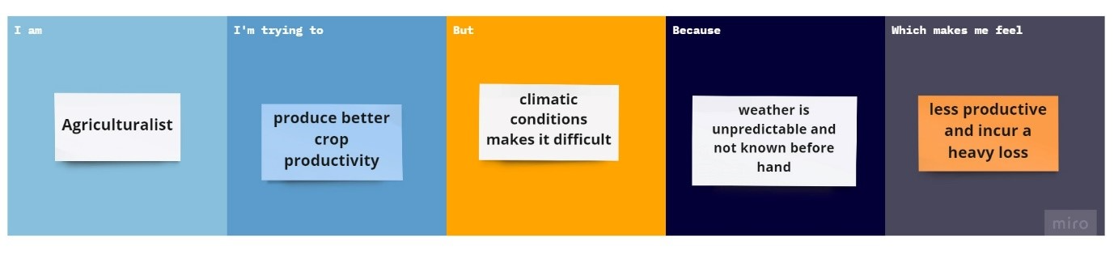

**3. IDEATION & PROPOSED SOLUTION**

**3.1 Empathy Map Canvas**

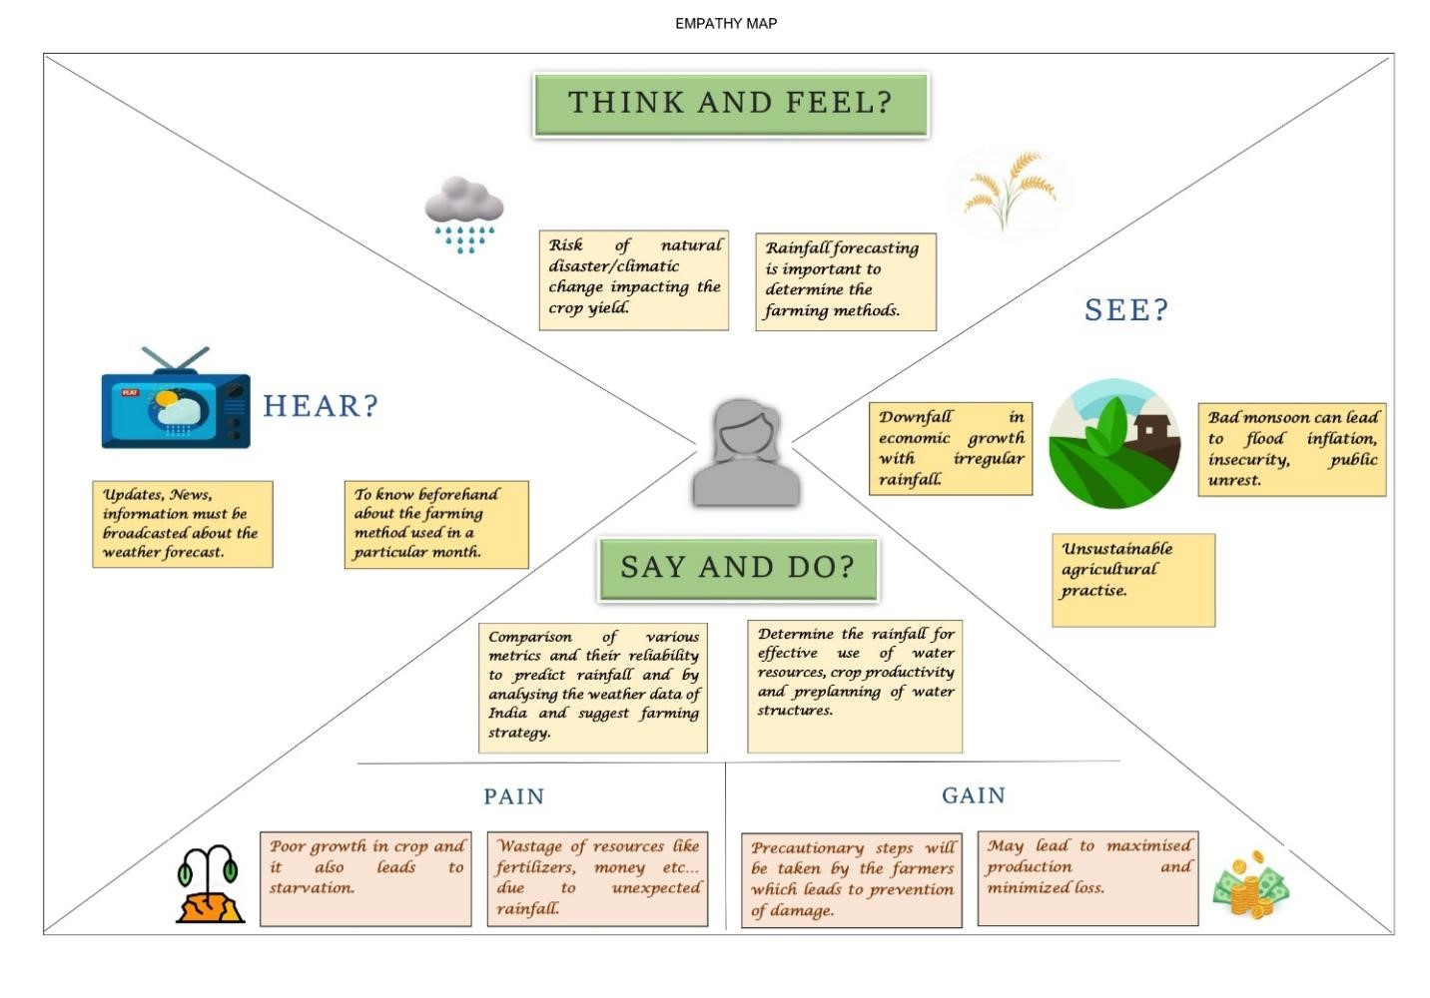

**3.2 Ideation & Brainstorming**

   Step-1: Team Gathering, Collaboration and Select the Problem Statement

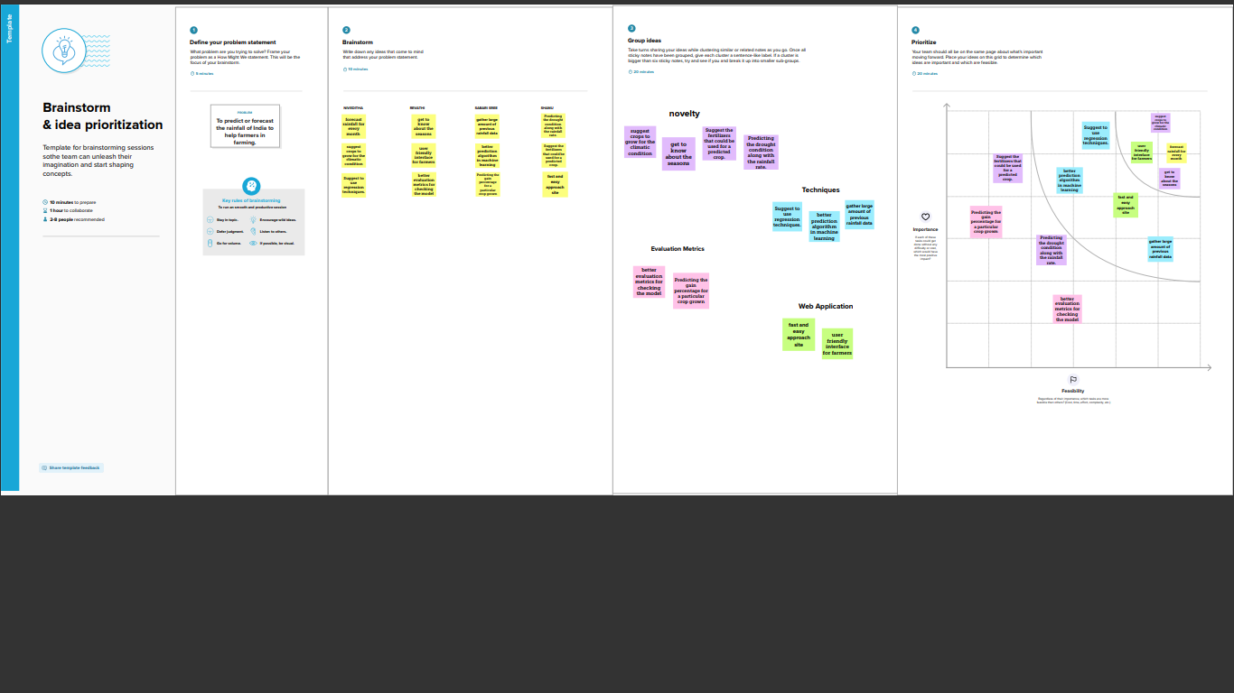

Step-2: Brainstorm, Idea Listing and Grouping



Step-3: Idea Prioritization



**3.3 Proposed Solution**

|  |  |  |
| --- | --- | --- |
| S.No. | Parameter | Description |
| 1 | Problem Statement (Problem to be solved) | To exactly determine the rainfall in India for effective use of water resources, crop productivity, and pre-planning of water structures. |
| 2 | Idea / Solution description | The idea is to predict the rainfall in a region by analyzing the weather data in India from 1998-2015. |
| 3 | Novelty / Uniqueness | Here with the given region we suggest the agriculturalist for the best yielding crops to grow. |
| 4 | Social Impact / Customer Satisfaction | Rainfall has been a major concern these days. Weather conditions have been changing for time being. Rainfall forecasting is important otherwise, it may lead to many disasters. Irregular heavy rainfall may lead to the destruction of crops, heavy floods that can cause harm to human life. |
| 5 | Business Model (Revenue Model) | The target of this project is to forecast the rainfall in India and the target user is the farmers. It provides a better service in predicting the rainfall and the crops to grow for better yield. |
| 6 | Scalability of the Solution | It aims to acquire a better scalability with highest accuracy achieved in prediction, user friendly interface, good number of web app users, without investing lot of resources and money, ease of use and works with better functionality. |

**3.4 Problem Solution fit**

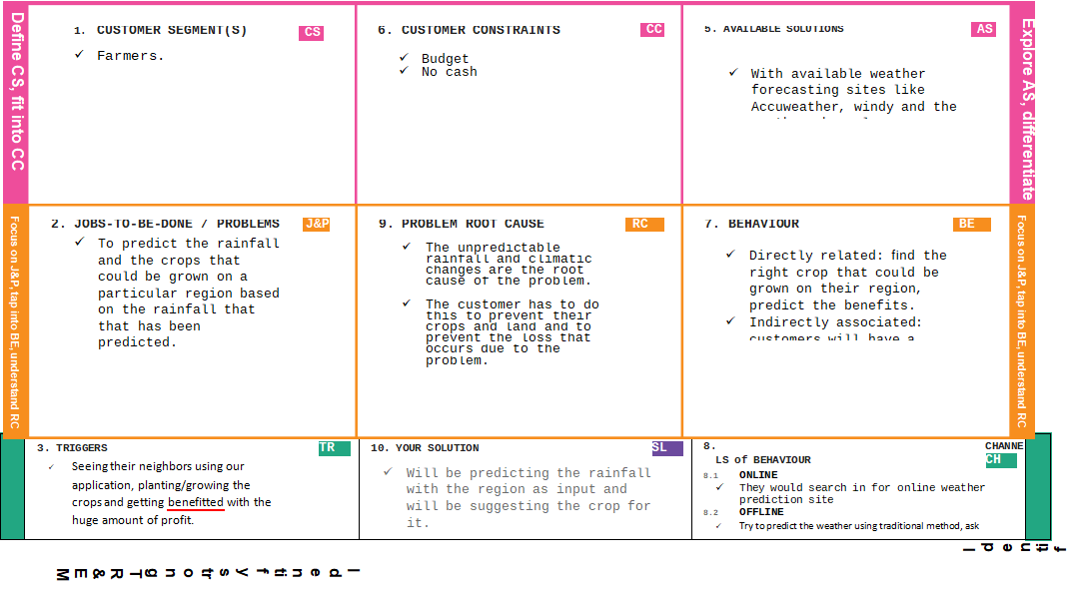

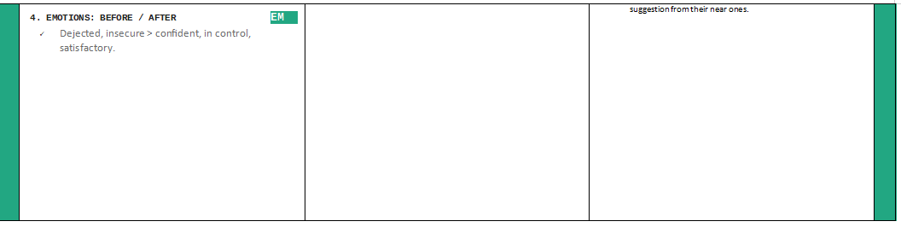

**4. REQUIREMENT ANALYSIS**

**4.1 Functional requirement**

Following are the functional requirements of the proposed solution.

|  |  |  |
| --- | --- | --- |
| FR No. | Functional Requirement (Epic) | Sub Requirement (Story / Sub-Task) |
| FR-1 | Check weather | Customer can check the rainfall by giving region and month as inputs. |
| FR-2 | Suggest crop | With the predicted rainfall, the crops would be suggested to the farmers for higher productivity |

**4.2 Non-Functional requirements**

Following are the non-functional requirements of the proposed solution.

|  |  |  |
| --- | --- | --- |
| FR No. | Non-Functional Requirement | Description |
| NFR-1 | Usability | The farmers and other people can easily use the application and it is user friendly no prior knowledge is required for using it. |
| NFR-2 | Security | All data will be protected against malware attacks. |
| NFR-3 | Reliability | The system will provide the prediction without any errors. |
| NFR-4 | Performance | The expected output will be produces immediately to the user without much delay. |
| NFR-5 | Availability | The system would be available 24/7 |
| NFR-6 | Scalability | The system would be available on web application and any user can login and use it without any disruptions. |

**5. PROJECT DESIGN**

**5.1 Data Flow Diagrams**

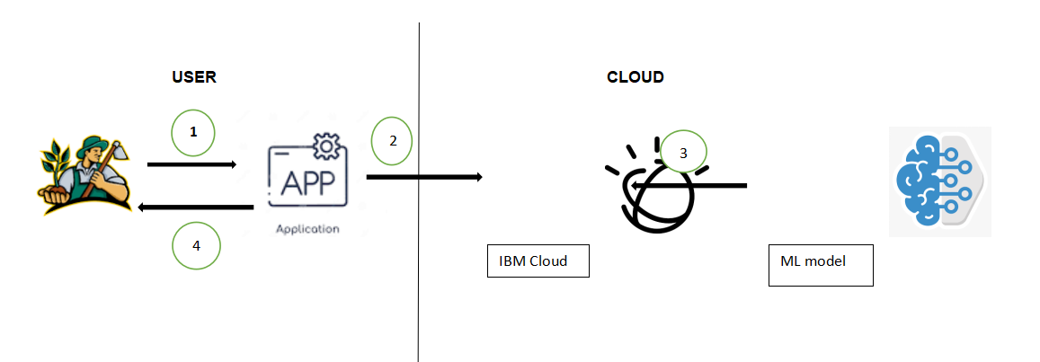

A Data Flow Diagram (DFD) is a traditional visual representation of the information flows within a system. A neat and clear DFD can depict the right amount of the system requirement graphically. It shows how data enters and leaves the system, what changes the information, and where data is stored. User enters the region into the web application to predict the rainfall rateThe input data is sent to the cloud The Machine learning model deployed in the cloud predicts the rainfall And finally the predicted rainfall rate in mm  and crops are suggested as output.Solution & Technical Architecture

**5.2 Solution and technical Architecture**

**Solution Architecture**

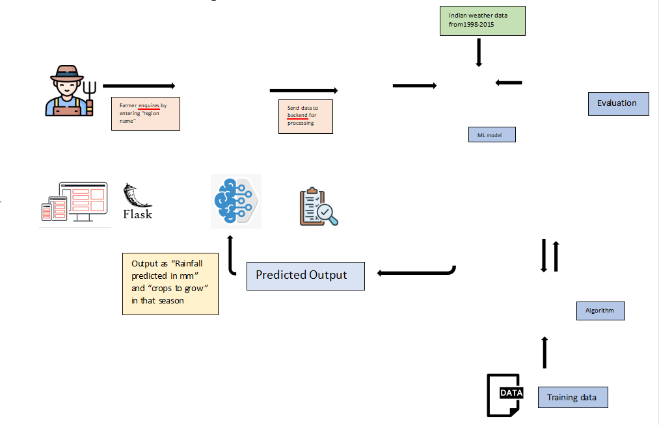

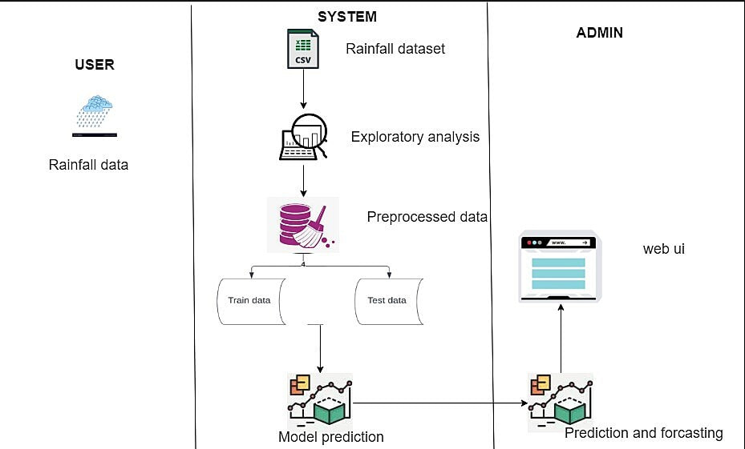

**Table-1 : Components & Technologies:**

|  |  |  |  |
| --- | --- | --- | --- |
| S.No | Component | Description | Technology |
| 1. | User Interface | The user interacts with the application through a webUI and a chatbot | HTML, CSS, python,flask |
| 2. | Application Logic-1 | Logic for a Registration | Python |
| 3. | Application Logic-2 | Logic for a loginthe application | Python |
| 4. | Application Logic-3 | Integrating machine learning model and the webpage | Flask |
| 5. | Database | Numeric data | MySQL |

|  |  |  |  |
| --- | --- | --- | --- |
| 6. | File Storage | To storefiles such as prediction report | Local Filesystem |
| 7. | External API-1 | Allows developers access to critical forecasts,  alerts, and observations, along with other weather data. | IBM WeatherAPI, etc. |
| 8. | Machine Learning Model | Predictive modeling is a statistical technique using machine learning and datamining to predictand  forecast likely future outcomes with the aid of historical and existing data | Predictive Model,etc. |
| 9. | Infrastructure (Server) | Application Deployment on Local System Local Server Configuration: built-in flask web server | Flask web server |

**Table-2: Application Characteristics:**

|  |  |  |  |
| --- | --- | --- | --- |
| S.No | Characteristics | Description | Technology |
| 1. | Open-Source Frameworks | Flask | Micro webframework written in Python |
| 2. | Security Implementations | Basic HTTP authentication, Session based authentication, User Registration, Login Tracking | Flask security |
| 3. | Scalable Architecture | Size is everything, and Flask’s statusas a microframework meansthat you can use it to grow a tech project such as a web app incredibly quickly. . |  |

|  |  |  |  |
| --- | --- | --- | --- |
|  |  | Its simplicity of use and few dependenciesenable it to run smoothlyeven as it scales up and up. |  |
| 4. | Availability | Higher compatibility with latest technologies and allows customization | Flask |
| 5. | Performance | Integrated supportfor unit testing.  RESTful requestdispatching.  Uses Jinja templating.  Support for secure cookies(client side sessions)  100% WSGI 1.0 compliant. | Flask |

**User Stories**

|  |  |  |  |  |  |  |
| --- | --- | --- | --- | --- | --- | --- |
| **User Type** | **Functional Requirement (Epic)** | **User Story Number** | **User Story / Task** | **Acceptance criteria** | **Priority** | **Release** |
| Customer (web user) | Check Weather | USN-1 | As a customer, I can check the rainfall by giving the region as input. | I can view the predicted rainfall status by entering information | High | Sprint-2 |
|  | Suggested Crop | USN-2 | As a customer, With the predicted rainfall I can view the suggested crops for higher productivity | I can view the suggested crops with the predicted rainfall | High | Sprint-2 |

**PROJECT PLANNING & SCHEDULING**

**Sprint Planning & Estimation**

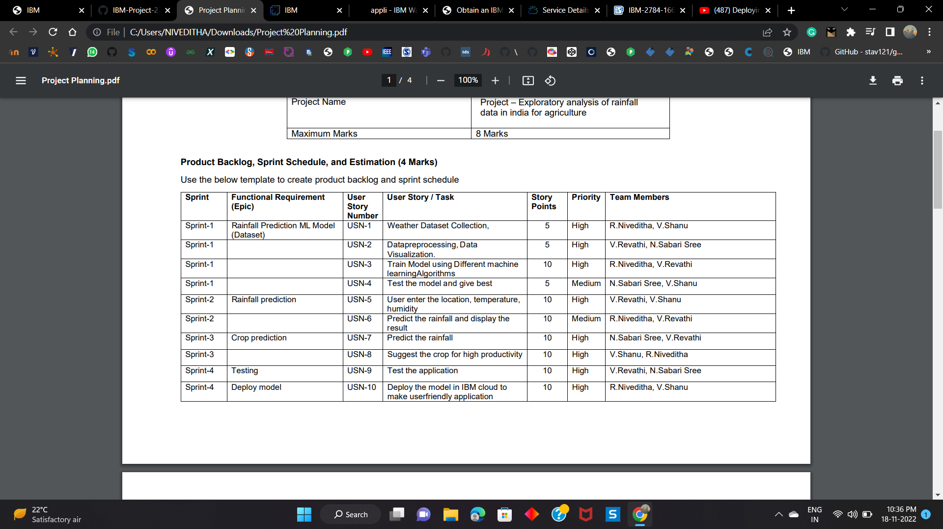

**Sprint Delivery Schedule**

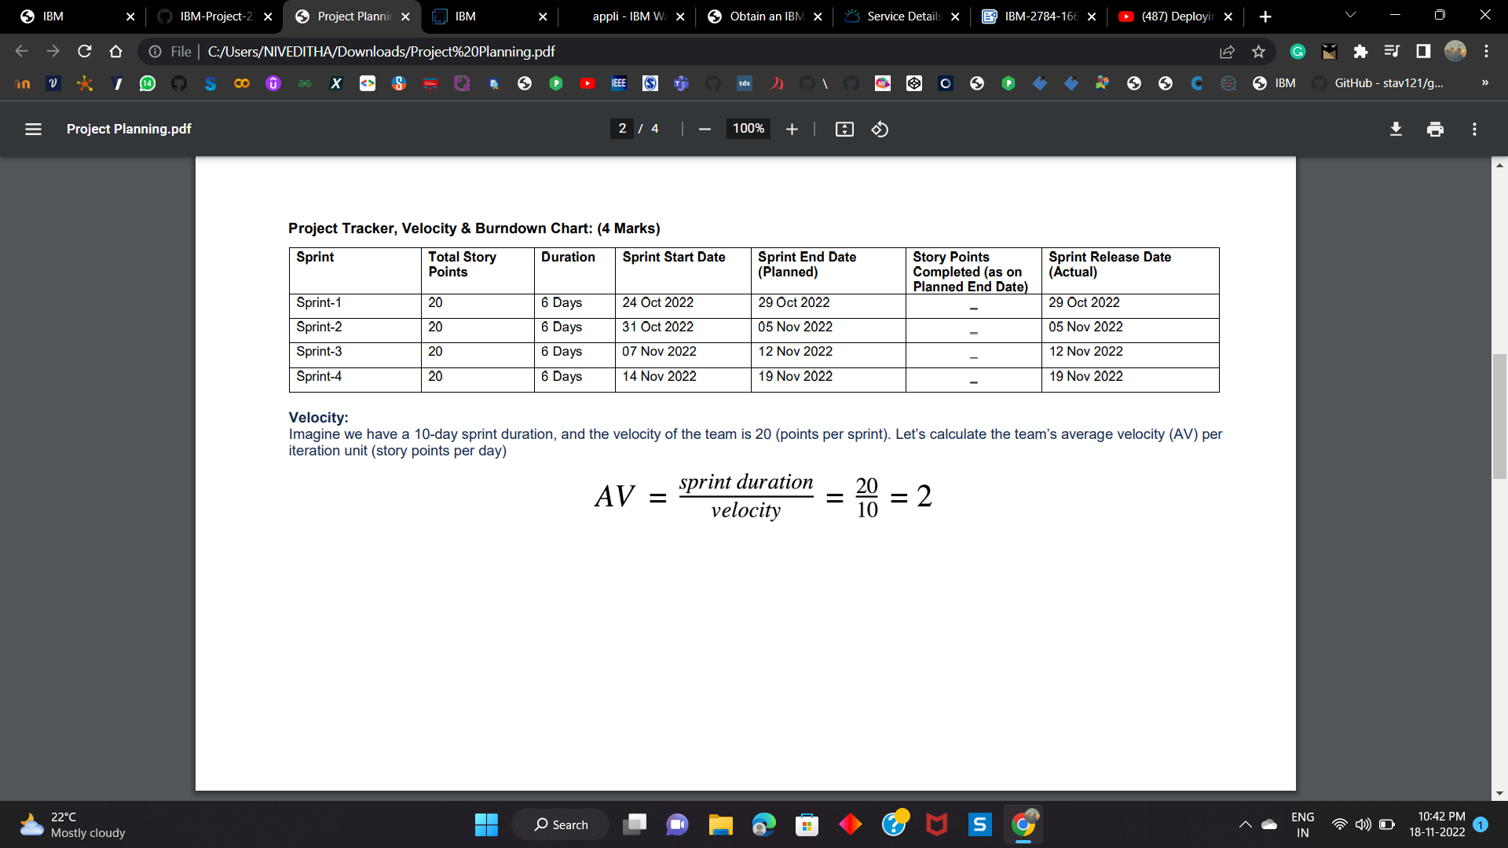

**Reports from JIRA**

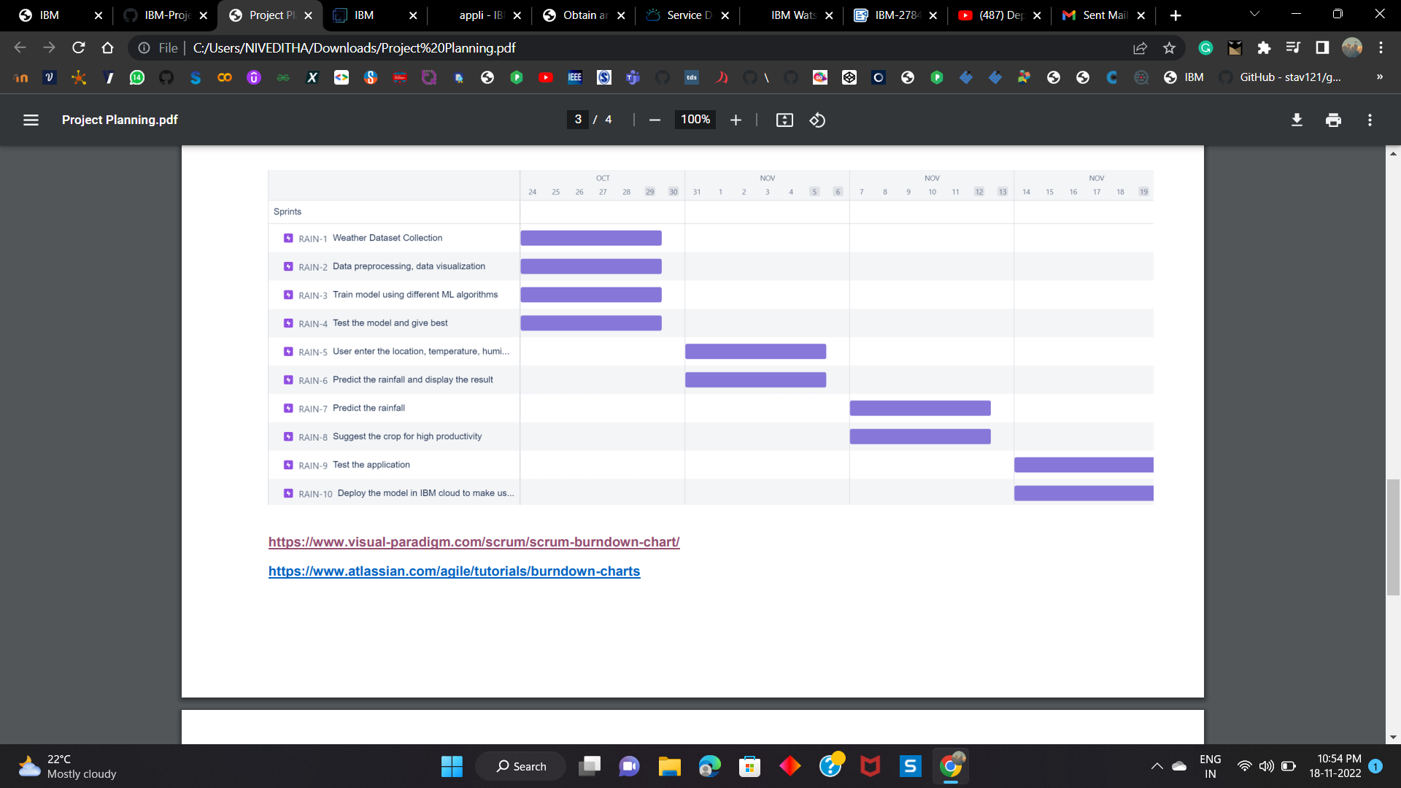

**CODING & SOLUTIONING (Explain the features added in the project along with code)**

**Feature 1**

For predicting the rainfall  rate for 5 different states.

import numpy as np

import pandas as pd

import pickle

from sklearn import metrics

data = pd.read_csv(r"C:/Users/NIVEDITHA/Downloads/rainfall.csv")

# data.head()

data = data.fillna(data.mean())

group = data.groupby('SUBDIVISION')['YEAR','JAN','FEB','MAR','APR','MAY','JUN','JUL','AUG','SEP','OCT','NOV','DEC']

dt=group.get_group(('TAMIL NADU'))

# data.head()

df=dt.melt(['YEAR']).reset_index()

# df.head()

df= df[['YEAR','variable','value']].reset_index().sort_values(by=['YEAR','index'])

# df.head()

df.columns=['Index','Year','Month','Avg_Rainfall']

Month_map={'JAN':1,'FEB':2,'MAR' :3,'APR':4,'MAY':5,'JUN':6,'JUL':7,'AUG':8,'SEP':9,

   'OCT':10,'NOV':11,'DEC':12}

df['Month']=df['Month'].map(Month_map)

# df.head(12)

df.drop(columns="Index",inplace=True)

X=np.asanyarray(df[['Month']]).astype('int')

y=np.asanyarray(df['Avg_Rainfall']).astype('int')

from sklearn.model_selection import train_test_split

X_train, X_test, y_train, y_test = train_test_split(X, y, test_size=0.3, random_state=10)

from sklearn.ensemble import RandomForestRegressor

random_forest_model = RandomForestRegressor(max_depth=100, max_features='sqrt', min_samples_leaf=4,

                      min_samples_split=10, n_estimators=800)

random_forest_model.fit(X_train, y_train)

#--------------------------------WEST BENGAL----------------------------------#

dt1=group.get_group(('WEST BENGAL'))

# data.head()

df1=dt1.melt(['YEAR']).reset_index()

# df.head()

df1= df1[['YEAR','variable','value']].reset_index().sort_values(by=['YEAR','index'])

# df.head()

df1.columns=['Index','Year','Month','Avg_Rainfall']

Month_map={'JAN':1,'FEB':2,'MAR' :3,'APR':4,'MAY':5,'JUN':6,'JUL':7,'AUG':8,'SEP':9,

   'OCT':10,'NOV':11,'DEC':12}

df1['Month']=df1['Month'].map(Month_map)

# df.head(12)

df1.drop(columns="Index",inplace=True)

X1=np.asanyarray(df1[['Month']]).astype('int')

y1=np.asanyarray(df1['Avg_Rainfall']).astype('int')

from sklearn.model_selection import train_test_split

X_train, X_test, y_train, y_test = train_test_split(X1, y1, test_size=0.3, random_state=10)

random_forest_model1 = RandomForestRegressor(max_depth=100, max_features='sqrt', min_samples_leaf=4,

                      min_samples_split=10, n_estimators=800)

random_forest_model1.fit(X_train, y_train)

#y_predict = random_forest_model.predict(X_test)

#print('MAE:', metrics.mean_absolute_error(y_test,y_predict))

# print('MSE:', metrics.mean_squared_error(y_test, y_predict))

#print('RMSE:', np.sqrt(metrics.mean_squared_error(y_test, y_predict)))

#------------------------------------ORISSA------------------------------------

dt2=group.get_group(('ORISSA'))

# data.head()

df2=dt2.melt(['YEAR']).reset_index()

# df.head()

df2= df2[['YEAR','variable','value']].reset_index().sort_values(by=['YEAR','index'])

# df.head()

df2.columns=['Index','Year','Month','Avg_Rainfall']

Month_map={'JAN':1,'FEB':2,'MAR' :3,'APR':4,'MAY':5,'JUN':6,'JUL':7,'AUG':8,'SEP':9,

   'OCT':10,'NOV':11,'DEC':12}

df2['Month']=df2['Month'].map(Month_map)

# df.head(12)

df2.drop(columns="Index",inplace=True)

X2=np.asanyarray(df2[['Month']]).astype('int')

y2=np.asanyarray(df2['Avg_Rainfall']).astype('int')

X_train, X_test, y_train, y_test = train_test_split(X2, y2, test_size=0.3, random_state=10)

random_forest_model2 = RandomForestRegressor(max_depth=100, max_features='sqrt', min_samples_leaf=4,

                      min_samples_split=10, n_estimators=800)

random_forest_model2.fit(X_train, y_train)

#-------------------------------------------PUNJAB----------------------------------------------

#group3= data.groupby('SUBDIVISION')['YEAR','JAN','FEB','MAR','APR','MAY','JUN','JUL','AUG','SEP','OCT','NOV','DEC']

dt3=group.get_group(("PUNJAB"))

# data.head()

df3=dt3.melt(['YEAR']).reset_index()

# df.head()

df3= df3[['YEAR','variable','value']].reset_index().sort_values(by=['YEAR','index'])

# df.head()

df3.columns=['Index','Year','Month','Avg_Rainfall']

Month_map={'JAN':1,'FEB':2,'MAR' :3,'APR':4,'MAY':5,'JUN':6,'JUL':7,'AUG':8,'SEP':9,

   'OCT':10,'NOV':11,'DEC':12}

df3['Month']=df3['Month'].map(Month_map)

# df.head(12)

df3.drop(columns="Index",inplace=True)

X3=np.asanyarray(df3[['Month']]).astype('int')

y3=np.asanyarray(df3['Avg_Rainfall']).astype('int')

X_train, X_test, y_train, y_test = train_test_split(X3, y3, test_size=0.3, random_state=10)

random_forest_model3 = RandomForestRegressor(max_depth=100, max_features='sqrt', min_samples_leaf=4,

                      min_samples_split=10, n_estimators=800)

random_forest_model3.fit(X_train, y_train)

#--------------------------------------------------UTTARAKHAND---------------------

dt4=group.get_group(('UTTARAKHAND'))

# data.head()

df4=dt4.melt(['YEAR']).reset_index()

# df.head()

df4= df4[['YEAR','variable','value']].reset_index().sort_values(by=['YEAR','index'])

# df.head()

df4.columns=['Index','Year','Month','Avg_Rainfall']

Month_map={'JAN':1,'FEB':2,'MAR' :3,'APR':4,'MAY':5,'JUN':6,'JUL':7,'AUG':8,'SEP':9,

   'OCT':10,'NOV':11,'DEC':12}

df4['Month']=df4['Month'].map(Month_map)

# df.head(12)

df4.drop(columns="Index",inplace=True)

X4=np.asanyarray(df4[['Month']]).astype('int')

y4=np.asanyarray(df4['Avg_Rainfall']).astype('int')

X_train, X_test, y_train, y_test = train_test_split(X4,y4, test_size=0.3, random_state=10)

random_forest_model4 = RandomForestRegressor(max_depth=100, max_features='sqrt', min_samples_leaf=4,

                      min_samples_split=10, n_estimators=800)

random_forest_model4.fit(X_train, y_train)

#-------------------------------------JAMMU & KASHMIR--------------------------------------

dt5=group.get_group(('JAMMU & KASHMIR'))

# data.head()

df5=dt5.melt(['YEAR']).reset_index()

# df.head()

df5= df5[['YEAR','variable','value']].reset_index().sort_values(by=['YEAR','index'])

# df.head()

df5.columns=['Index','Year','Month','Avg_Rainfall']

Month_map={'JAN':1,'FEB':2,'MAR' :3,'APR':4,'MAY':5,'JUN':6,'JUL':7,'AUG':8,'SEP':9,

   'OCT':10,'NOV':11,'DEC':12}

df5['Month']=df5['Month'].map(Month_map)

# df.head(12)

df5.drop(columns="Index",inplace=True)

X5=np.asanyarray(df5[['Month']]).astype('int')

y5=np.asanyarray(df5['Avg_Rainfall']).astype('int')

X_train, X_test, y_train, y_test = train_test_split(X5, y5, test_size=0.3, random_state=10)

random_forest_model5 = RandomForestRegressor(max_depth=100, max_features='sqrt', min_samples_leaf=4,

                      min_samples_split=10, n_estimators=800)

random_forest_model5.fit(X_train, y_train)

#----------------------------------------------------------------------------------

file = open("model.pkl","wb")

file1=open("model1.pkl","wb")

pickle.dump(random_forest_model,file)

pickle.dump(random_forest_model1,file1)

file.close()

file1.close()

file2 = open("model2.pkl","wb")

file3=open("model3.pkl","wb")

pickle.dump(random_forest_model2,file2)

pickle.dump(random_forest_model3,file3)

file2.close()

file3.close()

file4 = open("model4.pkl","wb")

file5=open("model5.pkl","wb")

pickle.dump(random_forest_model4,file4)

pickle.dump(random_forest_model5,file5)

file4.close()

file5.close()

# print(y_predict)

**Feature 2**

**For suggesting the better yielding crop with the rainfall predicted for a particular state.**

from flask import render_template,Flask,request

import pickle

from sklearn.neighbors import KNeighborsClassifier

from sklearn.model_selection import train_test_split

import pandas as pd

import numpy as np

from sklearn.ensemble import RandomForestClassifier

from sklearn.metrics import accuracy_score

from sklearn.tree import DecisionTreeClassifier

from sklearn.naive_bayes import GaussianNB

dt = pd.read_csv(r"C:/Users/NIVEDITHA/Downloads/Crop_recommendation.csv")

# Create feature and target arrays

train=dt['rainfall']

target=dt['label']

train=np.array(train)

target=np.array(target)

# Split into training and test set

X_train, X_test, y_train, y_test = train_test_split(

             train,target, test_size = 0.3, random_state=1)

knn = GaussianNB()

knn.fit(X_train.reshape(-1,1), y_train)

pred=knn.predict(X_test.reshape(-1,1))

print(accuracy_score(y_test,pred))

appl=Flask(__name__)

file=open("model.pkl","rb")

file1=open("model1.pkl","rb")

file2=open("model2.pkl","rb")

file3=open("model3.pkl","rb")

file4=open("model4.pkl","rb")

file5=open("model5.pkl","rb")

random_Forest=pickle.load(file)

file.close()

random_Forest1=pickle.load(file1)

file1.close()

random_Forest2=pickle.load(file2)

file2.close()

random_Forest3=pickle.load(file3)

file3.close()

random_Forest4=pickle.load(file4)

file4.close()

random_Forest5=pickle.load(file5)

file5.close()

#random_Forest=pickle.load(file)

#file.close()

@appl.route("/", methods=["GET","POST"])

def home():

    if request.method=="POST":

        myDict = request.form

        Month = int(myDict["Month"])

        state= (myDict["state"])

        pred = [Month]

        #stateCall(state)

        #res=random_Forest.predict([pred])[0]

        if(state=="TAMILNADU"):

            res=random_Forest.predict([pred])[0]

        elif state=="WEST BENGAL":

            res=random_Forest1.predict([pred])[0]

        elif(state=="ORISSA"):

            res=random_Forest2.predict([pred])[0]

        elif(state=="PUNJAB"):

            res=random_Forest3.predict([pred])[0]

        elif(state=="UTTARAKHAND"):

            res=random_Forest4.predict([pred])[0]

        else:

            res=random_Forest5.predict([pred])[0]

        res=round(res,2)

        ans=knn.predict([[res]])[0]

        return render_template('result.html',Month=Month,state=state,res=res,ans=ans)

    return render_template('index.html')

if __name__ == "__main__":

    appl.run(debug=True)

**8. TESTING**

**8.1 Test Cases**

|  |  |
| --- | --- |
| INPUT | PREDICTED OUTPUT |
| MONTH :12  STATE:WEST BENGAL | The Rainfall rate is 6.42 mm  Can plant papaya for good yield |
| MONTH:9  STATE:JAMMU & KASHMIR | The Rainfall rate is 85.23 mm  Can plant chickpea for good yield |
| MONTH:2  STATE:TAMILNADU | The Rainfall rate is 11.17 mm  Can plant papaya for good yield |
| MONTH:1  STATE:ASSAM | The Rainfall rate is 100.92 mm  Can plant banana for good yield |

**8.2 User Acceptance Testing**

**Defect Analysis**

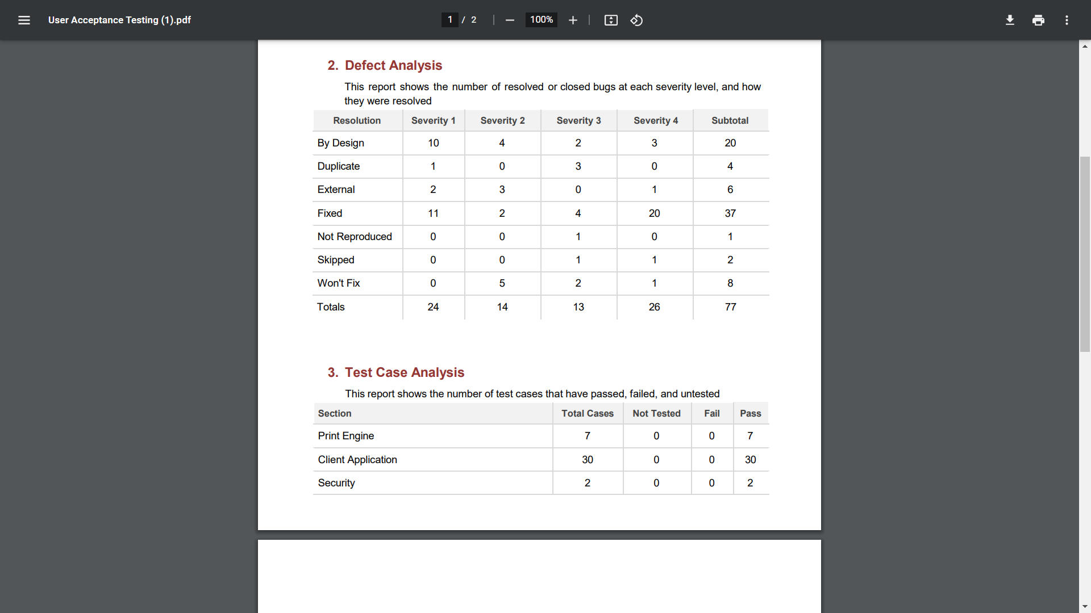

**TestCase analysis**

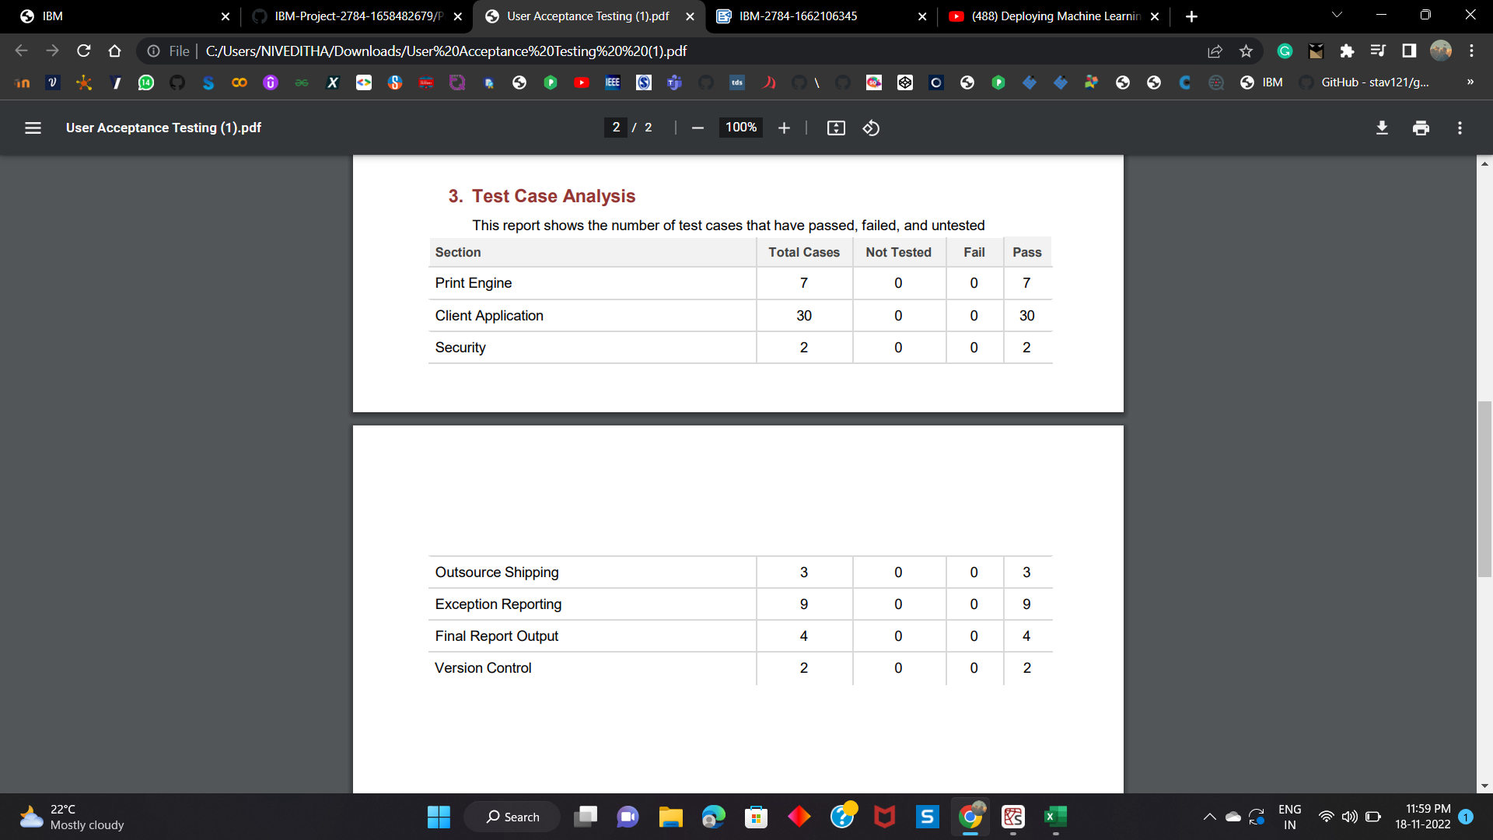

**9.RESULTS**

**9.1.Performance Metrics**

y_test_predict=rfmodel.predict(X_test)

print("-------Test Data--------")

print('MAE:', metrics.mean_absolute_error(y_test, y_test_predict))

print('MSE:', metrics.mean_squared_error(y_test, y_test_predict))

print('RMSE:', np.sqrt(metrics.mean_squared_error(y_test, y_test_predict)))

-------TestData--------  
MAE:82.07252495976634  
MSE:20286.85437242721  
RMSE: 142.4319289079075

**10.ADVANTAGES**

1. Predicting the rainfall for a month can help them plan for the many day-to-day decisions. These decisions include crop irrigation, time to fertilize, and what days are suitable for working in the field. The decisions that farmers make will result in a profitable crop or failure.
2. Crop suggested can help farmers to acheive a better yield and high business-profit.
3. Weather forecast helps in controlling the pests and other crop diseases to spread over the field. Weather factors can influence crop-destroying pests.

**DISADVANTAGES**

1. Only predicted for certain states and not for all ,due to unavailability of data's.
2. Provides information only for a month and not for individual days .
3. Provides only what crop to plant for the particular month in a state.

**11.CONCLUSION**

Sometimes farmers in India occur loss due to false predictions of weather. Now that 9the technology is developed and special weather forecasting mechanisms are available, the farmers can get all the updates are on a smartphone. Education towards that is, of course, an important thing but most of the farmer population at this stage knows the basics which make it easy for them to use the features. Most field crops are dependent solely upon weather to provide life‐sustaining water and energy. Livestock are also dependent upon weather for their comfort and food supplies.Our machine learning model can thus, help all the farmers and agriculturalists to predict or forecast the rainfall for a particular month with the Rainfall datset and further gets to know about the crop to grow for getting high yield and good profit with the crop recommendation dataset.

**12.FUTURE SCOPE**

In future ,the forecasting of weather and precise details about the crops can be  recommended.Unlike  our  weather prediction model, forecast systems that use machine learning are not constrained by the physical laws that govern the atmosphere. So it’s possible that they could produce unrealistic results – for example, forecasting temperature extremes beyond the bounds of nature. And it is unclear how they will perform during highly unusual or unprecedented weather phenomena. So techinques can be used to improve the accuracy by using large amount of weather data.

**13.APPENDIX**

**Source Code**

**WEBPAGE CREATION CODE**

**index.html //The home page to get input from end-users**

<!DOCTYPE html>

<html lang="en">

<head>

    <meta charset="UTF-8">

<linkrel="stylesheet" href="https://stackpath.bootstrapcdn.com/bootstrap/4.3.1/css/bootstrap.min.css" integrity="sha384-ggOyR0iXCbMQv3Xipma34MD+dH/1fQ784/j6cY/iJTQUOhcWr7x9JvoRxT2MZw1T" crossorigin="anonymous">

    <title>Rainfall-Prediction</title>

</head>

<style>

body{

background-image: url('https://i.gifer.com/A4XX.gif') ;

background-repeat: no-repeat;

  background-attachment: fixed;

  background-size: cover;

  }

  </style>

  <body>

  <br><br><br><br>

<div class="container">

    <h1 class="text-center m-3 badge-dark text-wrap">

        Rainfall Prediction for India

      </h1>

        <div class="card container" style="width: 65%; ">

            <div class="card-body">

                <form action="/" method="post">

                    <div class="form-group">

                      <label for="formGroupExampleInput1">MONTH</label>

                      <input

                        type="text"

                        class="form-control"

                        id="formGroupExampleInput1"

                        name="Month"

                        required

                      />

                    </div>

                    <div class="form-group">

                      <label for="formGroupExampleInput2">STATE</label>

                      <input

                        type="text"

                        class="form-control"

                        id="formGroupExampleInput2"

                        name="state"

                        required

                      />

                    </div>

                    <center><button type="submit" class="btn btn-dark">CHECK</button></center>

                  </form>

            </div>

        </div>

    </div>

</body>

</html>

**result.html //The output is displayed in this page**

<!DOCTYPE html>

<html lang="en">

<head>

    <meta charset="UTF-8">

    <link rel="stylesheet" href="https://stackpath.bootstrapcdn.com/bootstrap/4.3.1/css/bootstrap.min.css" integrity="sha384-ggOyR0iXCbMQv3Xipma34MD+dH/1fQ784/j6cY/iJTQUOhcWr7x9JvoRxT2MZw1T" crossorigin="anonymous">

    <title>Rainfall-Prediction</title>

</head>

<style>

body{

background-image: url('https://i.gifer.com/A4XX.gif') ;

background-repeat: no-repeat;

  background-attachment: fixed;

  background-size: cover;

  }

  </style>

<body >

<br><br><br><br>

    <div class="container" >

    <h1 class="text-center m-3 badge-dark text-wrap">Rainfall Prediction</h1>

        <div class="card container" style="width: 50%;">

            <div class="card-body" >

                    <form action="/" method="post">

                        <div class="form-group">

                          <label for="formGroupExampleInput1">Month</label>

                          <input

                            type="text"

                            class="form-control"

                            id="formGroupExampleInput1"

                            name="Month"

                            placeholder="{{Month}}"

                            required

                          />

                        </div>

                        <div class="form-group">

                          <label for="formGroupExampleInput2">state</label>

                          <input

                            type="text"

                            class="form-control"

                            id="formGroupExampleInput2"

                            name="Year"

                            placeholder="{{state}}"

                            required

                          />

                        </div>

                        <h2 class="text-center  text-wrap" >The Rainfall rate is {{res}} mm </h2>

                        <h2 class="text-center  text-wrap">Can plant {{ans}} for good yield</h2>

                      </form>

                    </div>

                      <center><a href="/"><button type="submit" class="btn btn-dark">Back</button></a></center>

                    </div>

    </div>

</body>

</html>

**GitHub  link:**

<https://github.com/IBM-EPBL/IBM-Project-2784-1658482679.git>

**Project Demo Link:**

<https://drive.google.com/file/d/1eEb7PMwI7nGDLYJSqb4r18khoa11uti7/view?usp=share_link>